**FUNDAMENTAL WEB**

**ACTIVITY PERTEMUAN 6**

**(SERVER CONTROL DAN CSS)**

**LEMBAR JAWABAN**

Nama : Ali Akbar Said

NPM : 50421119

Hari / Tanggal : Jumat, 03 Desember 2021

1. **Input Source.aspx:**

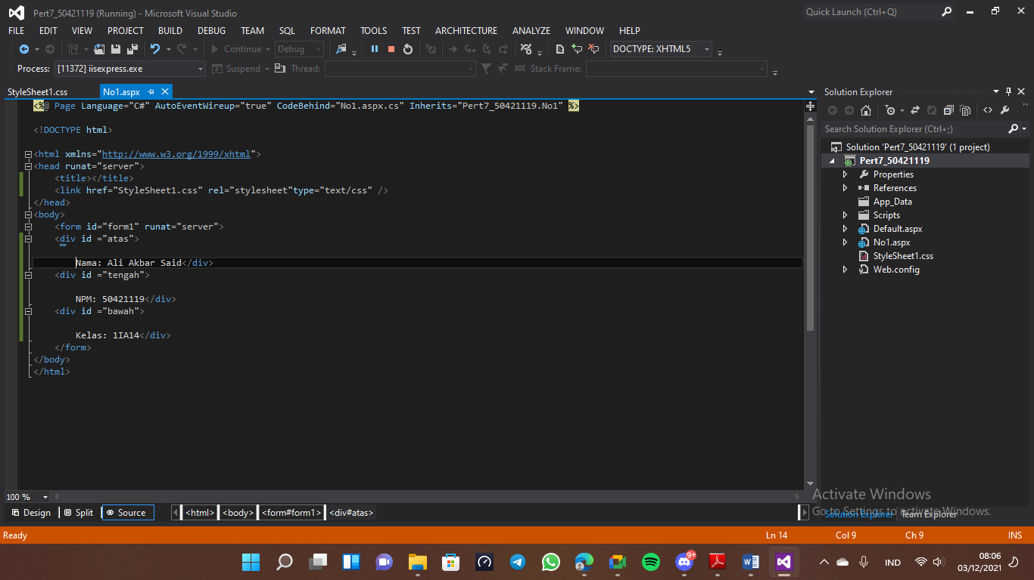

**Input Design.aspx:**

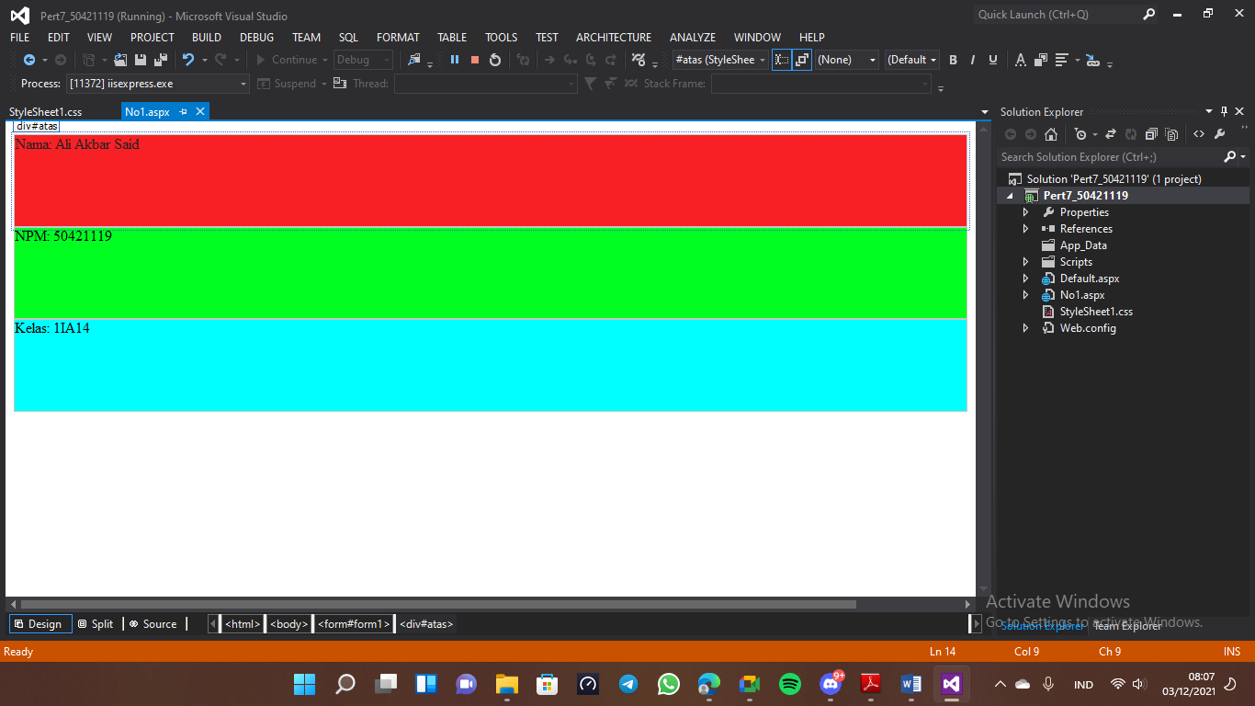

**Input StyleSheet1.css:**

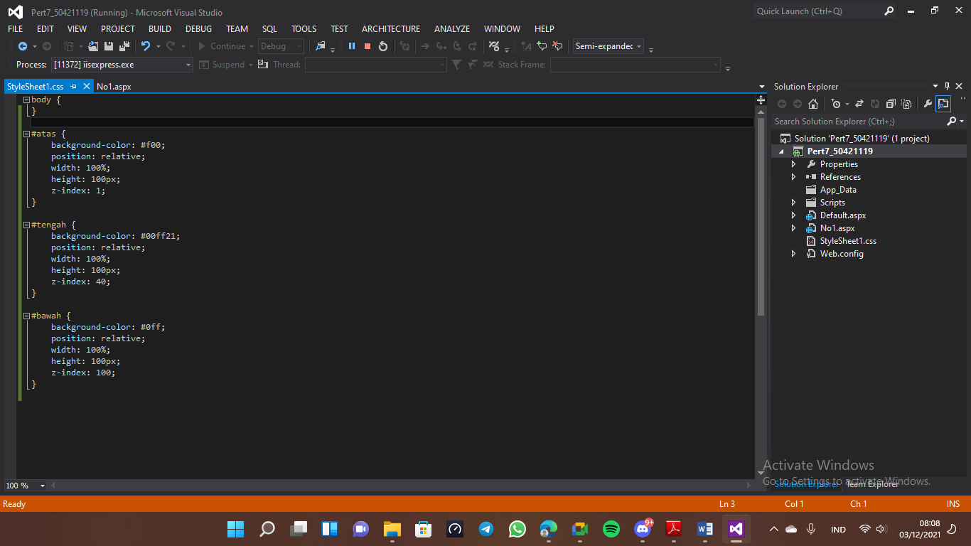

**Output:**

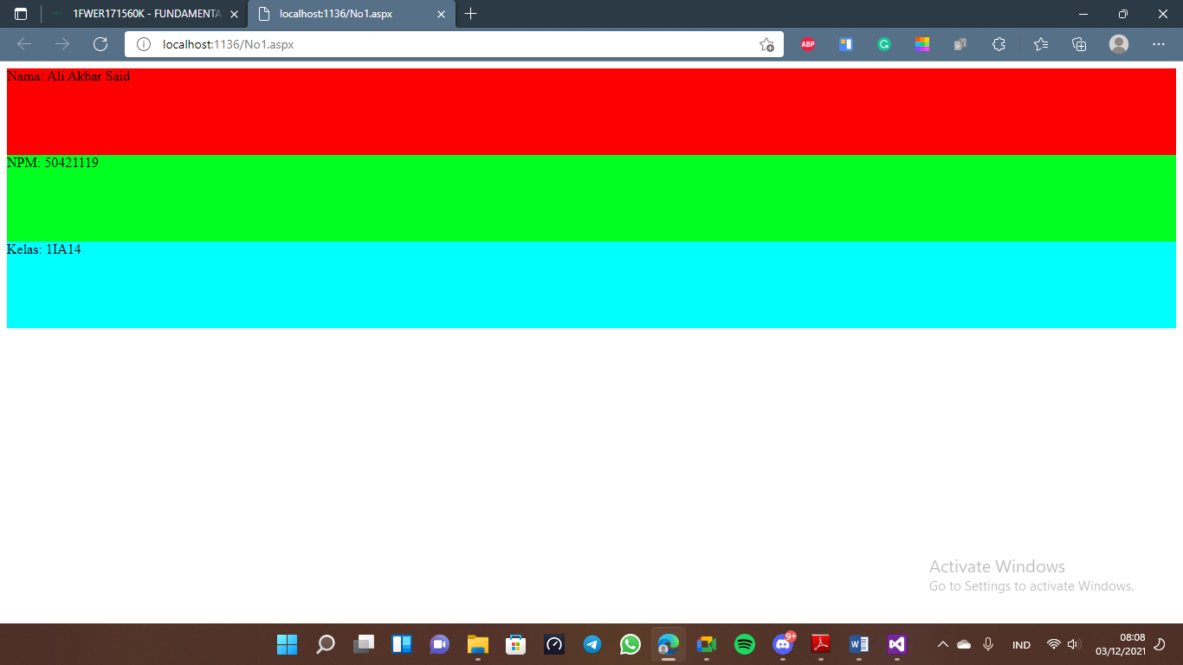

1. **Input .aspx.cs:**

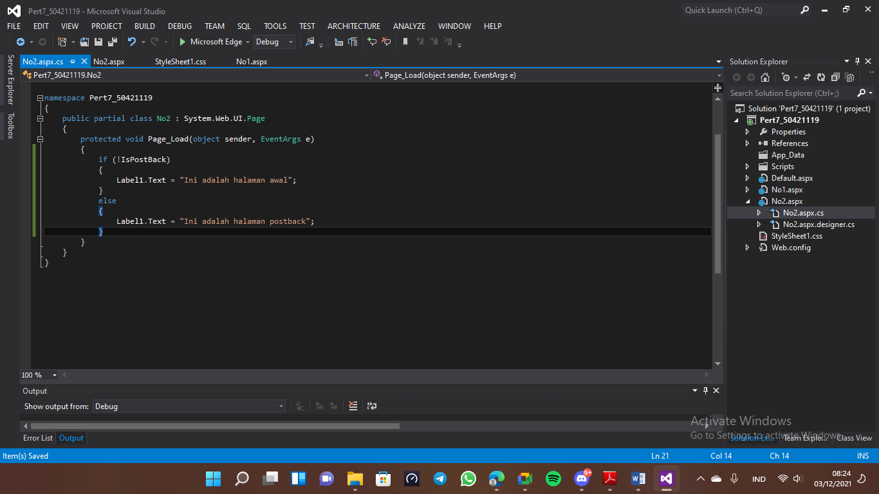

1. **Input source.aspx:**

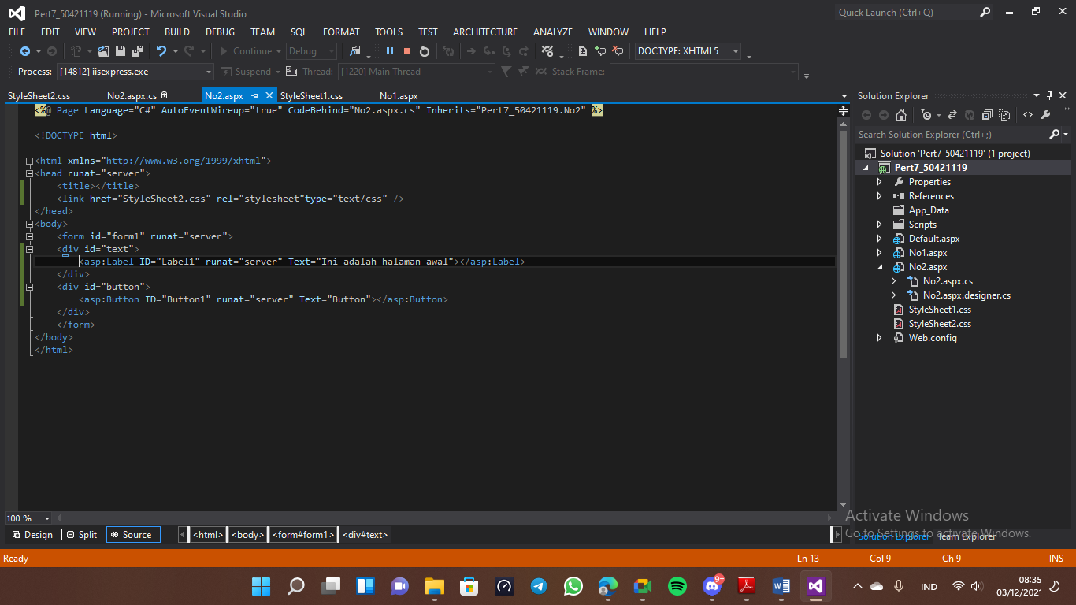

**Input design.aspx:**

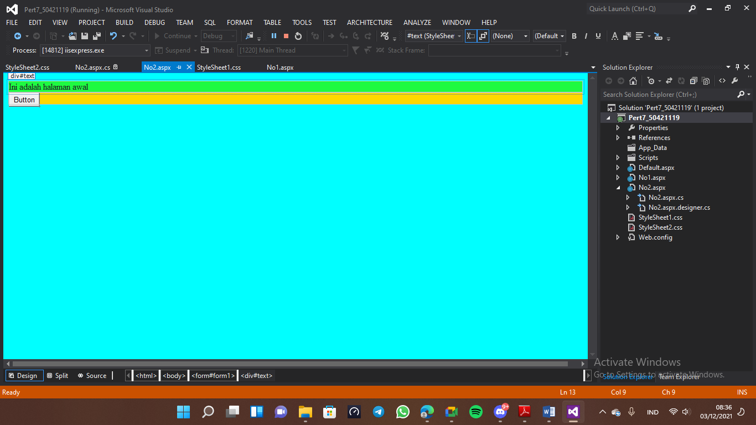

**Input StyleSheet2.css:**

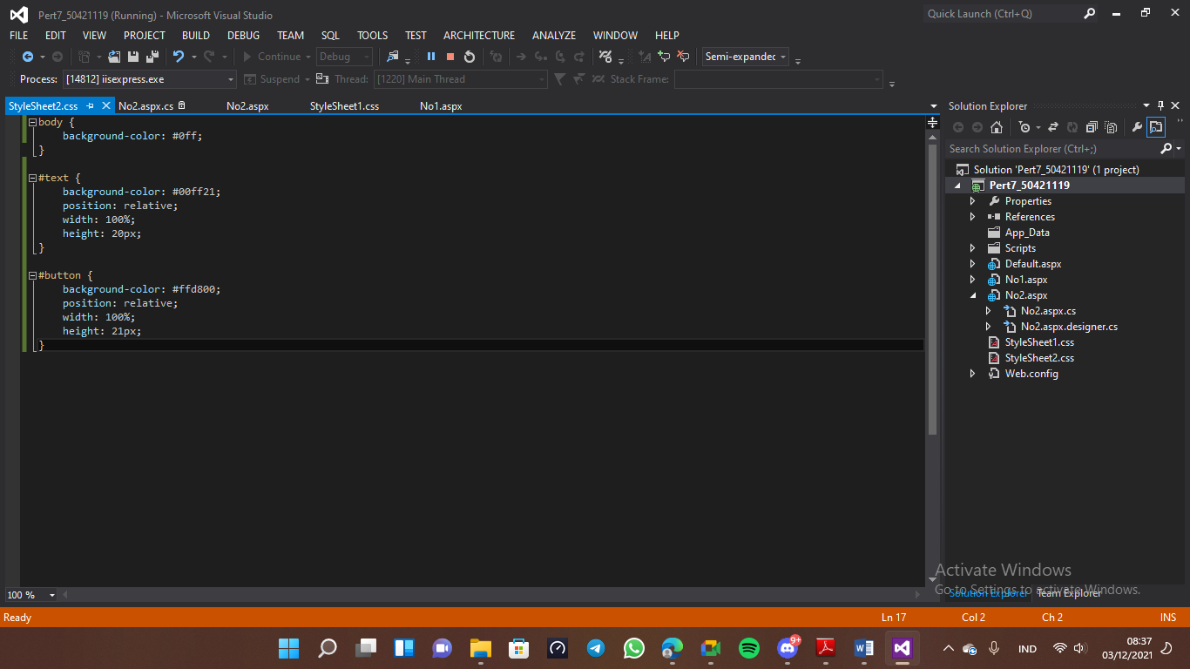

**Output:**

